Nguyễn Thanh Xuân Tùng
ITITIU16144

Introduction to AI
Lab 01

1) Load Lab 1_Read_Analysic_Data file, open and Run Read_data_csv.ipynb file
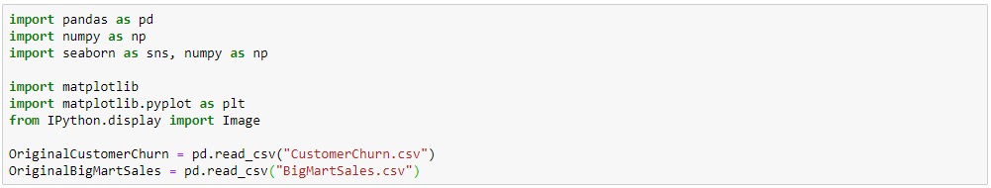

2) Show the Dataset Customer Churn and BigMartSales
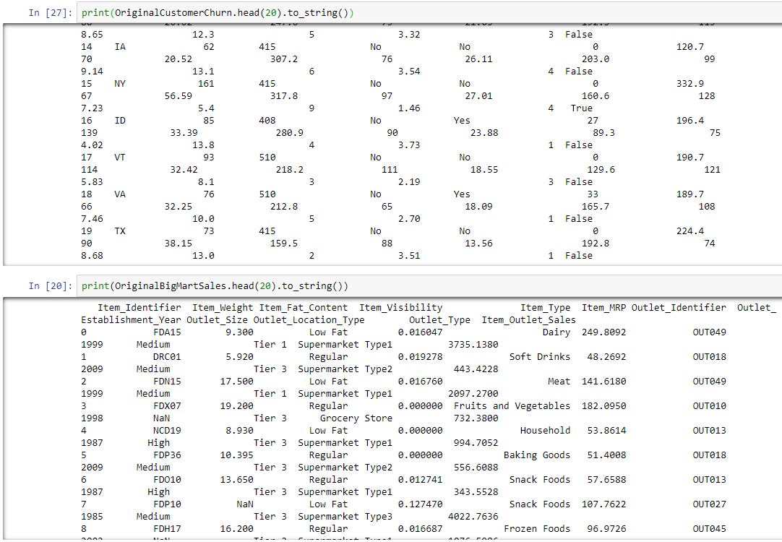

3) Use isnull().sum() to check the percentage of missing values of 2 Datasets in each variable
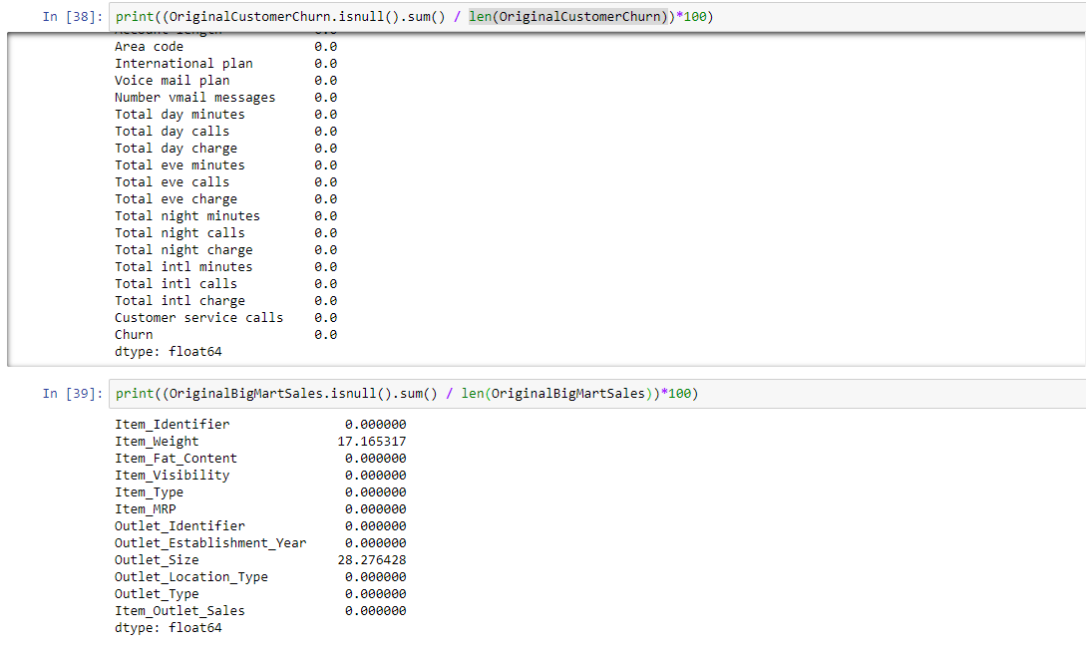

4) Create and describe data OriginalCustomerChurn.
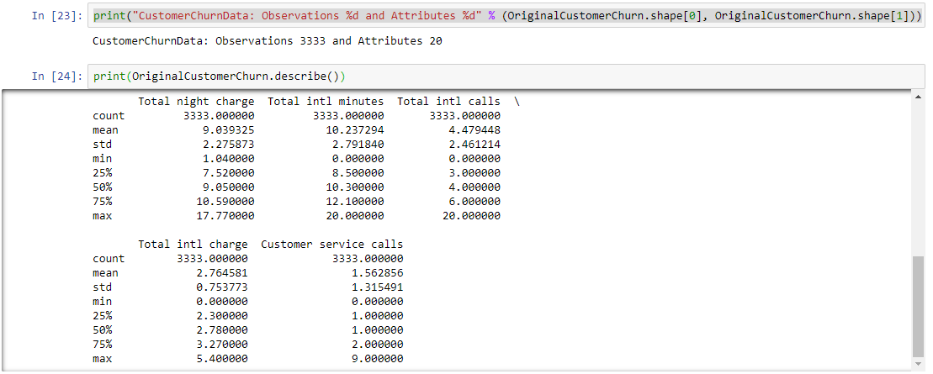

6) Create and describe data OriginalBigMartSales.
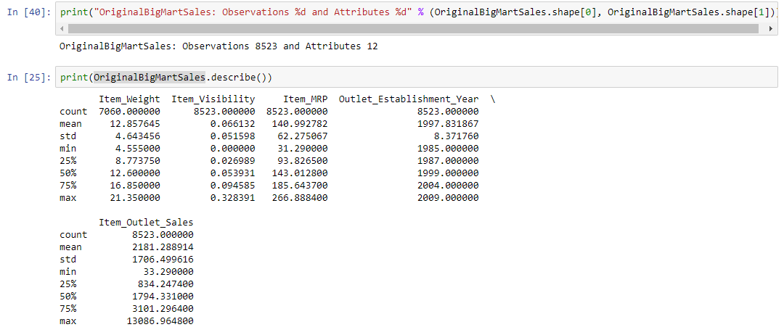

7) Use sns.distplot to show histogram plot with bin size =20 and determined “Total day minutes”
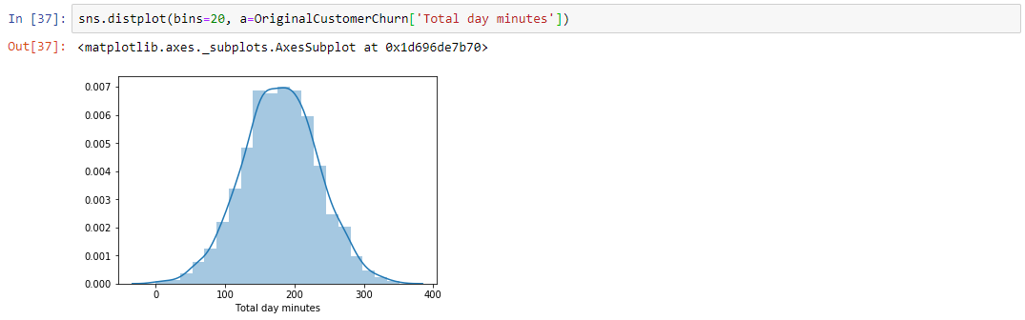

8) Data Visualization: draw Bar, Count, Histograms, Box, Pie for OriginalCustomerChurn
Bar:
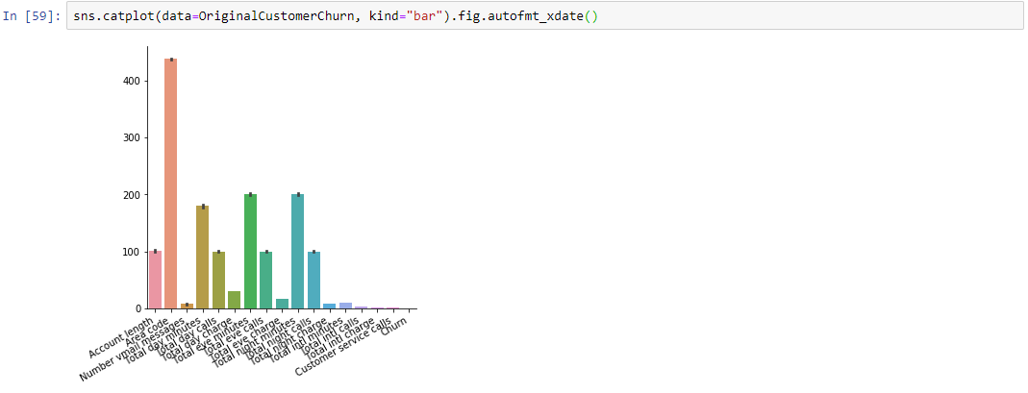
Count:
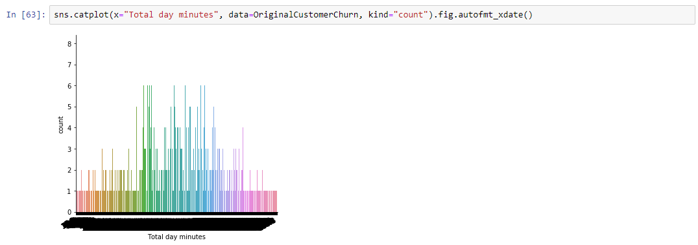
Histogram:
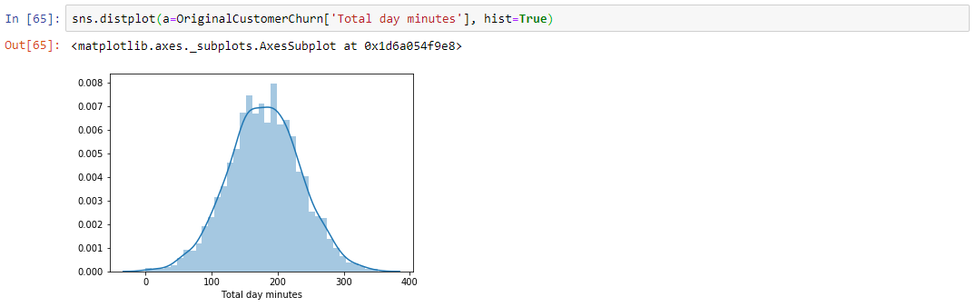
Box:
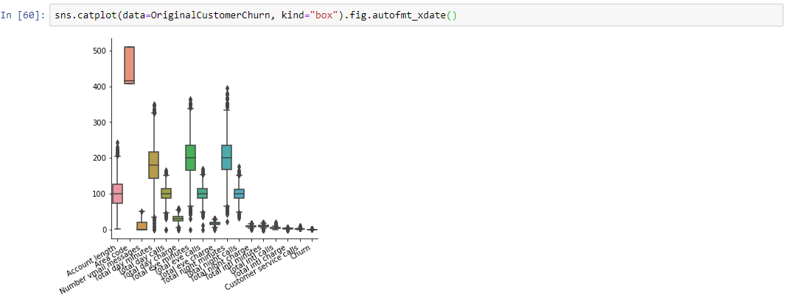
Pie:
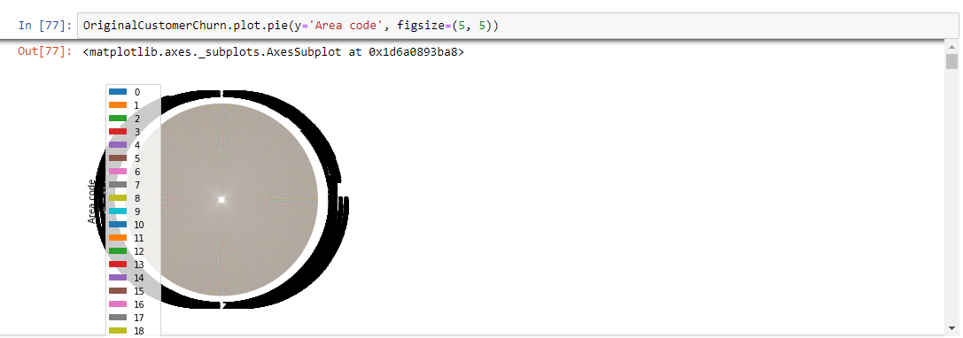

9) Data encoding for State, International Plan, Voice mail plan of OriginalCustomerChurn data.
